Project Retrospective

This document summarizes the project's timeline, including the significant events, how the project was developed, and the final thoughts from the team.

The timeline of the essential milestones in the project is presented. The project spanned three months, starting on the 5th of February, 2023, and ending on the 1st of May, 2023. Within these months, check-in submissions were provided to ensure the quality and improvement of the project, which was obtained through the guidance of Dr. Isabelle Bichindaritz.

Milestones Timeline:
- Project Proposal: February 5, 2023
- User Stories: February 19, 2023
- Requirements: March 5, 2023
- Design: April 2, 2023
- Code & Testing: April 30, 2023
- Presentation & ePortfolio: May 14, 2023

Ideally, each milestone and check-in must be equally divided and worked up to the utmost ability of the team members.

The energy graph for each project team member from the start until the final turn-in of the presentation and ePortfolio is seen below. Energy level is scored from -5 (lowest) to 5 (highest).

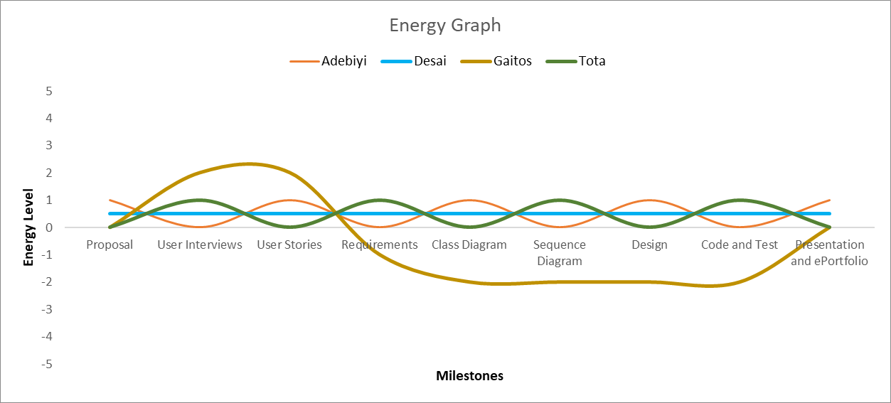

This project started pretty well. Everyone was looking forward to creating something out of nothing. This project was planned to be a WIFI- or Bluetooth-connected glucometer device that would automatically send the information obtained from the device to the ideal cloud or server project. The data obtained would be accessible to individuals, such as patients, permitted relatives/family members, and clinicians. Initially, an application for the project was planned. Still, due to the complexity of the processes of creating and designing software applications, members opted to build and design a website instead.

Due to the lack of time and the complexity of the idea, everyone still believed it would be best to stick with what was presented. But, everyone definitely thought of improvements that needed to be implemented in the project, along with enforcing everyone to proofread the papers to eliminate inconsistencies. Effective and valuable meetings to brainstorm and to check in on everyone’s ideas would have gotten the project to the next level. It would have been better if the codes were integrated to see if they worked cohesively and effectively. More classes would have been coded if given more time.

Everyone must realize that developing and designing a system is not a one-man show. It requires collective input, constructive criticism, and wild imaginations from hard-working people with the same passion for creating innovations.

The project was not completed. Only selected classes were coded and tested. Everyone thought it would have been better to acquire more information about developing software applications and integration on databases to utilize the project's full potential.

